

IT Staff Augmentation Contracts (ITSAC) Portal

Customer User Guide

Version: 3.0

Chief Procurement Office (CPO)  
Effective Date: 10/01/2020

# Service Solicitation Request (SSR) – Customer

The Customer ITSAC Portal will be used to post Solicitation Requests (either Request for Resumes or Statement of Work Solicitations), review details related to submitted Solicitations, cancel/withdraw the Solicitation, review candidates submitted by Vendors or Vendor SOW Responses, and ultimately Award the Solicitation and mark which candidates or Vendors were hired or selected.

Note: Customers are encouraged to use the ITSAC Portal to help manage the Solicitation process, but may choose to do this process manually via Email.

## **Submitting a Request for Resumes Solicitation**

## Open a web browser and navigate to the DIR website at <https://dir.texas.gov/>.

*Note:* The ITSAC Portal is optimized for Google Chrome or Mozilla Firefox.

## Click on the **Sign into My DIR** button.

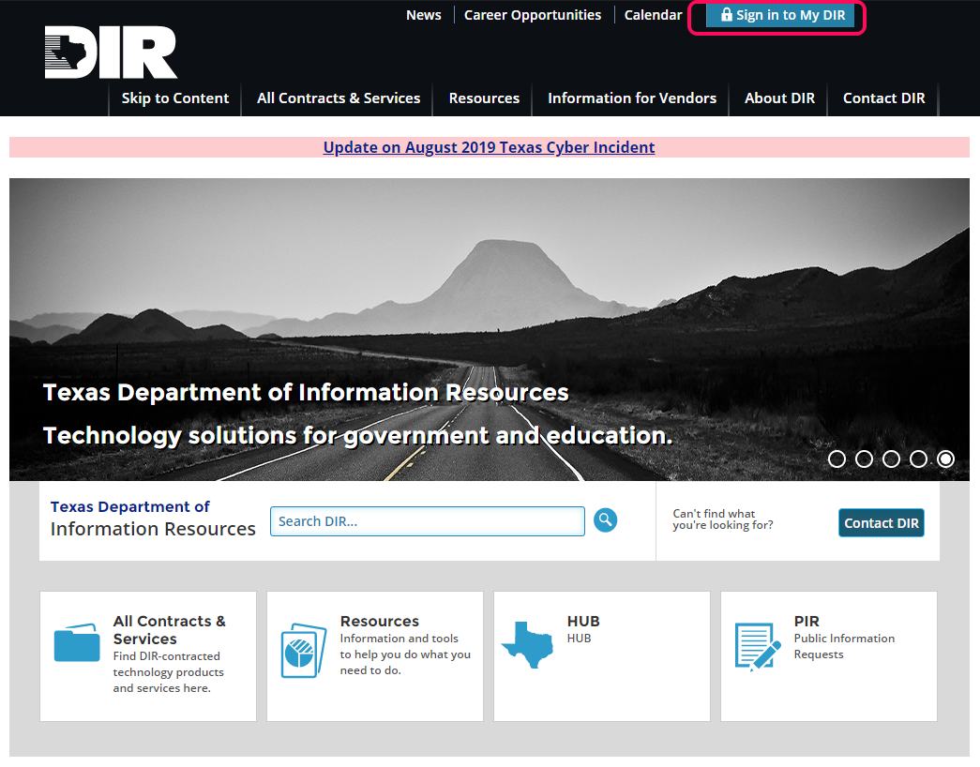

## Navigate to the DIR ITSAC Customer Portal link.

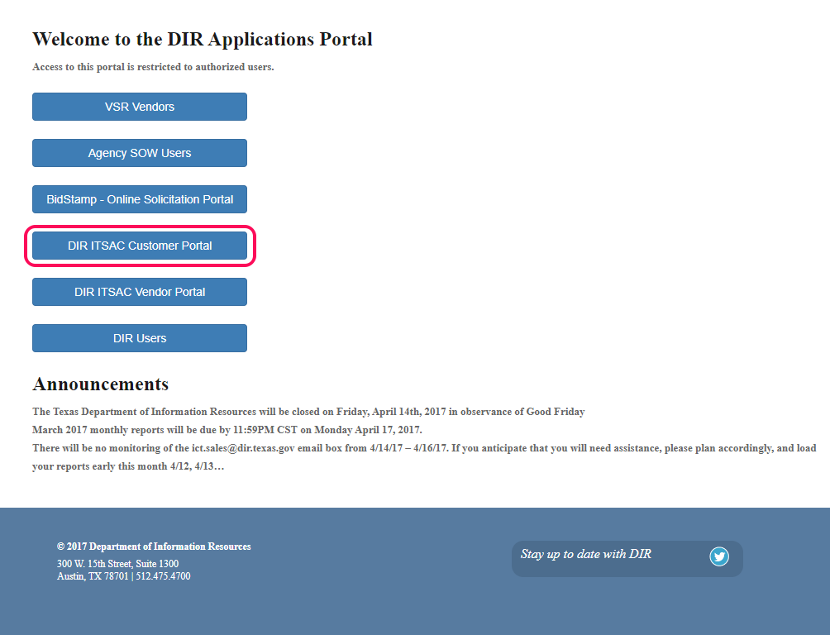

## Log into the ITSAC Portal with your credentials.

*Note:* Request a temporary password by clicking on the **Forgot your password?** link. If you do not have an account, click on the **Need a Login?** button.

Enter the following information and DIR Staff will review your account request.

*Note:* Multiple accounts per customer are allowed and can be requested through the portal. However, users are restricted to only view solicitations that was posted by their account. If a solicitation owner needs to be transferred to a different user, contact DIR Staff at [DIRStaffAugmentation@dir.texas.gov](mailto:DIRStaffAugmentation@dir.texas.gov).

## Once logged in, submit a new Solicitation Request by clicking on the **Submit New Request for Resumes** link.

## **New Request for Resumes Solicitation**

Solicitation Details - Begin the Solicitation Request by entering the following information. Click **Next** once complete.

*Note:* The Solicitation Reference Number is a unique value that is created and assigned by the Customer for reference throughout the Solicitation process.

*Note:* At any time during the process, click on the Home button to exit the Solicitation submission. Do **not** use your browser back arrow.

## Job Details - Enter the following Job details then click Next.

Note: If the position can be done remotely, enter ‘Work from Home’ or ‘Remote Work’ in the ‘Work Location’ field.

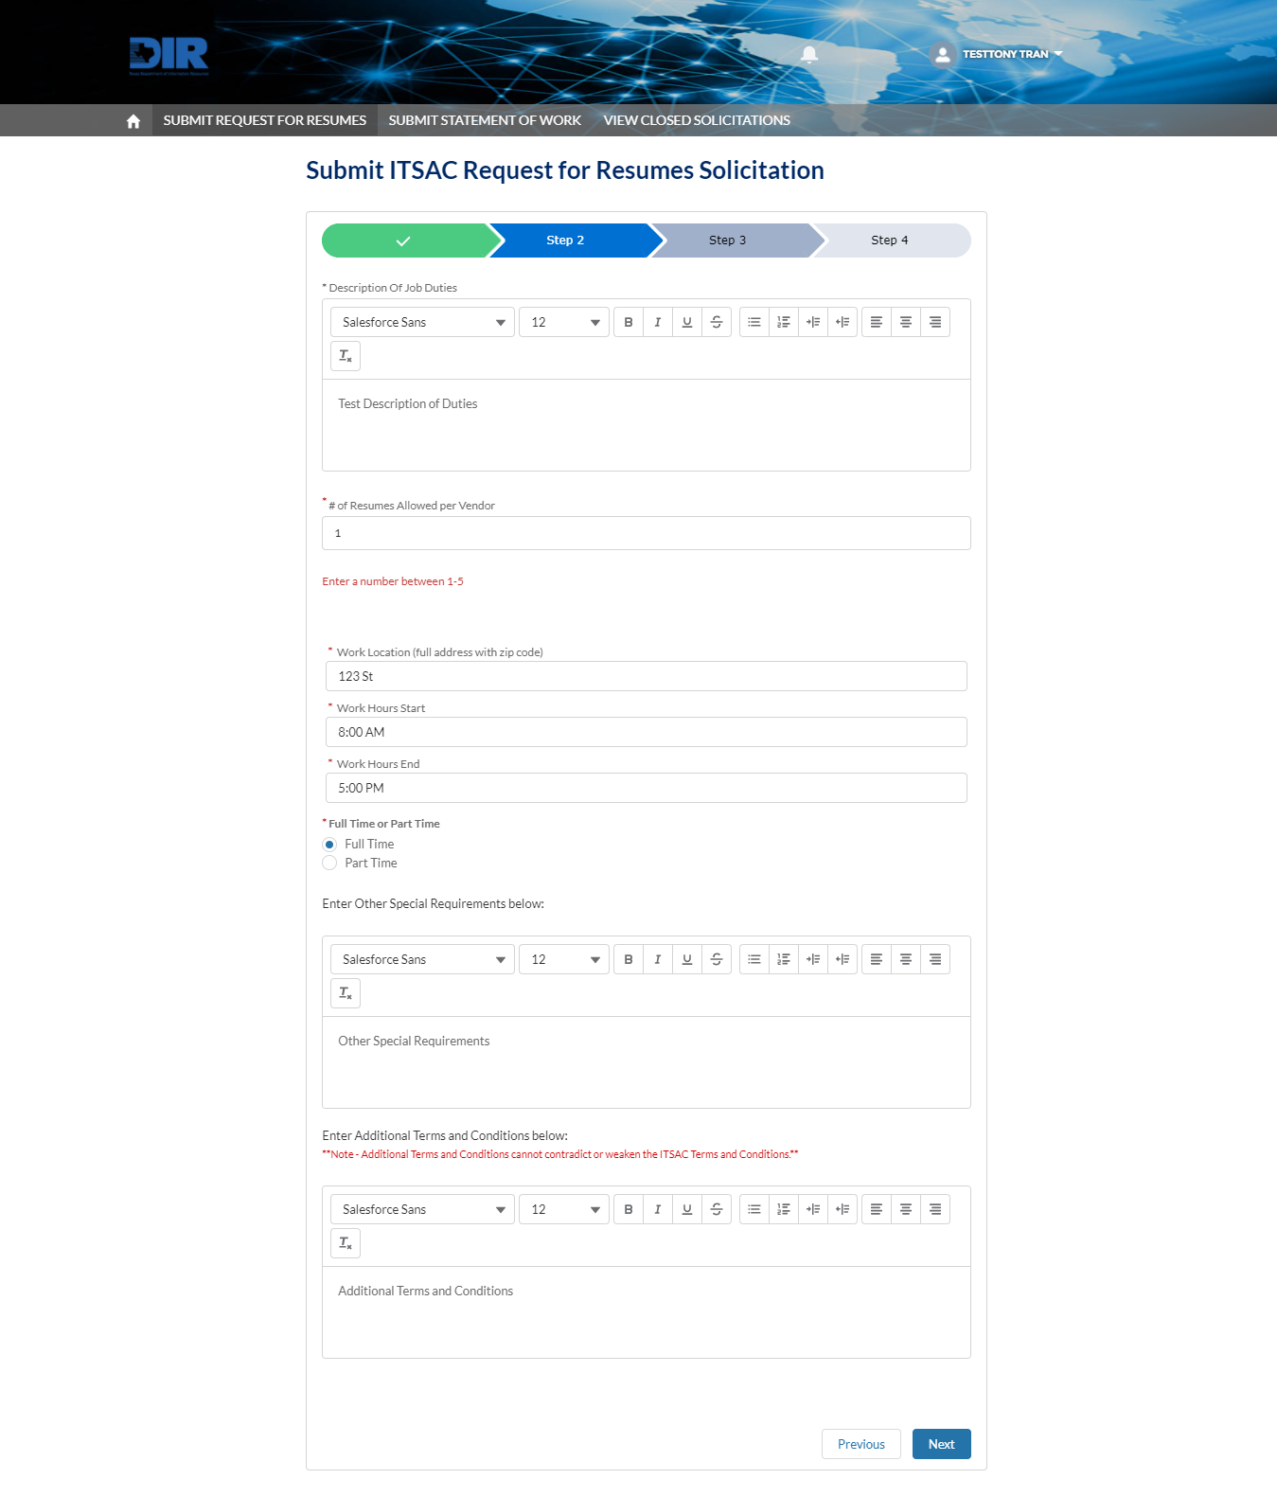

## Job Details (cont.) – Enter the **Job Category, Title, and Level.** Refer to contract documentation under RFO 445 for detailed explanations of the following:

## Defined Title – Refers to a set Category, Title, and Level with a defined Not To Exceed (NTE) Rate. For example, a Category **IT Marketing**, Title of **Customer Relationship Management (CRM),** and Level of **Intern 2** has a NTE Hourly rate of $29.26.

## Undefined Title – Refers to set a Category, but an Undefined Title. A Suggest Title and Suggested Rate will be required for Vendors to reference. For example, a Category of **Technical Services, Help Desk and Operations** can have an **Undefined Title,** a Suggested Title of **Drone Operator,** and a Suggested Rate of **$99.50.**

## Specialist Level – Refers to a set Category and Title, but has a Specialist Rate because of specific skills or job duties that exceed the DIR Job Category and Title. For example, a Category of **Project Management,** Title of **Agile Scrum Master,** and a **Specialist** level. Note: The rate will be negotiated between the Customer and Vendor and will be finalized during Award.

## Candidate Skills – Based on contract requirements for the job posting, add the **Required Skill(s)** and the corresponding minimum required number of Years. You may also add any Preferred Skills with the corresponding number of years. Note – Undefined Titles and Specialist Rates do not require a defined number of years for skills.

Click on the **Range of Years of Experience for All Types/Levels** for a tablelized contract reference list of Categories, Titles, Min. and Max. # of Years of Experience, and NTE Rates.

*Note:* Number of Years for Required or Preferred Skills must be a numeric value. For skills that do not have a numeric value (such as certificates), default to 1.

Click **Save Draft** once complete. A confirmation message will be displayed once the Solicitation has been drafted and saved. Click **Finish** to be re-directed to the Home Page.

*Note:* The Solicitation is in a **Draft** status and must be Posted with a Deadline Date before eligible vendors are notified. It is advisable for you to review the draft solicitation documents within your agency prior to posting for vendor responses.

## Review Solicitation – On the ITSAC Customer Home Page, all Solicitations and their current status is displayed (see table below). Click on the **Solicitation Reference Number Link** of the draft Solicitation to review and make final edits prior to posting.

*Note:* Solicitations can have the following statuses:

|  |  |
| --- | --- |
| Solicitation Status | Description |
| Draft | Solicitations that have been created by the Customer but has not been posted and sent to vendors for review. A deadline date has not been set and few edits can be done prior to posting. |
| Posted | Solicitations that have been posted and sent to vendors for review. Vendors can review and submit candidates up until the Deadline Date. |
| Customer Reviewing | Solicitations that have passed the Deadline Date. Customer can review all eligible candidates and begin the selection process. |
| Awarded | Solicitations that have been awarded by the customer and candidate(s) have been interviewed and hired. |
| Cancelled | Solicitations that have been cancelled by the Customer after the Solicitation has been posted. |
| Closed – No Response | Solicitations that have been posted and the deadline date has passed but no Candidates have been submitted by Vendors.  *Note:* If you wish to re-submit a Solicitation, submit a New Solicitation with the previously used Solicitation Reference ID with a ‘R’ added to the end. |

Selecting a Solicitation will contain three tabs: **Solicitation, Request Detail,** and **Candidates.**

## Solicitation – This tab will contain the Word document of the Solicitation Request. Click **Download Solicitation** to save a local copy.

*Note:* Once the Solicitation is posted, a list of notified vendors and the corresponding contract number will appear at the bottom of this page.

## Request Detail – Contains details regarding the Solicitation.

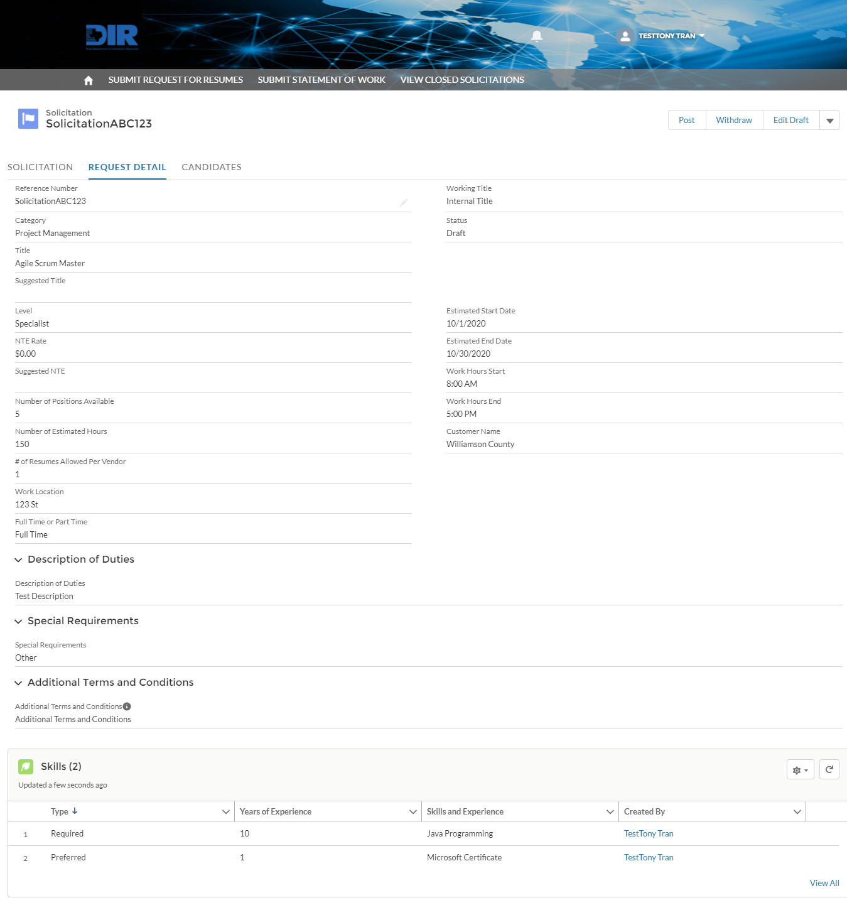

To make any edits, click on the **Edit Draft** button to launch the wizard-view for the Solicitation.

Changes will be saved on Step 5 when clicking **Save Draft.**

## Candidates – Candidates will not be reviewable until the Solicitation has been posted, vendors have submitted candidates, and the Deadline Date has passed.

*Note:* You will be able to view the number of candidates that have been submitted at any time. Use this information to determine whether the solicitation deadline should be extended. This number is not final and can fluctuate at any time.

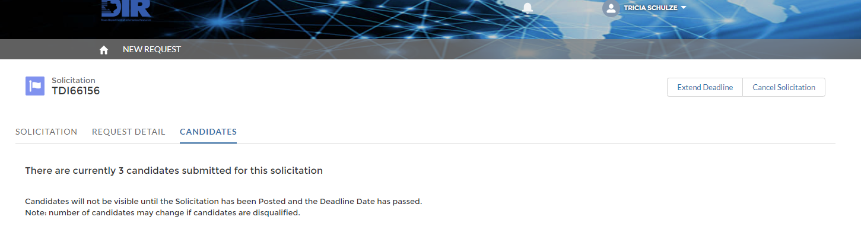

*Note:* If changes need to be made to the Deadline Date after posting, navigate to the Solicitation and click on the **Extend Deadline** button. For any other changes, the Solicitation must be withdrawn or cancelled, then resubmitted. Re-submit quickly using the **Clone Solicitation** button on any Solicitation.

## Posting Solicitation – Once the Solicitation is reviewed and updated, click on the **Post** button and enter the **Deadline Date** for vendors to submit candidates. Click **Next** once complete.

Note: If you are a State Agency, you will need to accept the following acknowledgement per TGC 2157.068.

Click **Next** to view a list of Vendors to post the Solicitation to.

Click Save to post the Solicitation and allow Vendors to post Candidates.

## Confirmation – The email associated with your account and chosen vendors will receive an email notification of the Solicitation posting. Click **Finish** on the confirmation message to be directed to the Home page.

Note: The Solicitation status is updated from ‘Draft’ to ‘Posted’ with a Deadline Date.

Example of Vendor Email notification:

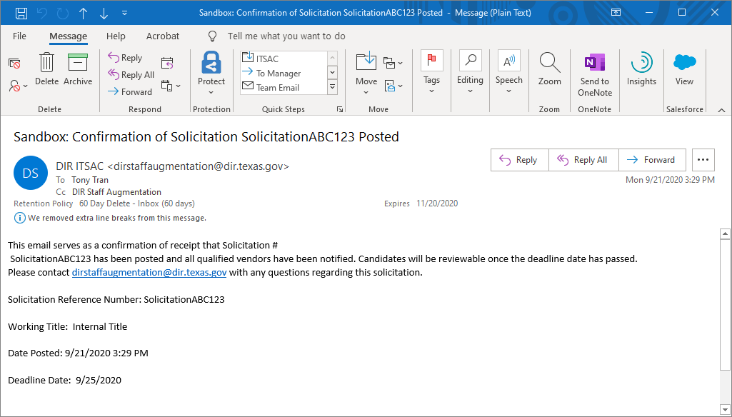

*Note:* Contact your IT Department to ensure that emails coming from DIR are whitelisted and not marked as spam.

## Cancel Solicitation – At any point after the posting of the Solicitation, Customers may cancel the Solicitation by clicking on the Solicitation link and clicking the **Cancel** button. A picture containing bird Description automatically generated

Provide the cancellation reason then click **Next.**

All eligible vendors will be notified via email of the cancellation.

## **Awarding a Request for Resumes Solicitation**

At 5:00 PM (Central Time) on the Deadline Date, vendors will no longer be able to submit candidates and the Solicitation will be reviewable for award. Customers will be able to review the submitted candidates and begin reaching out to selected vendors for negotiations, and possible Award

## Navigate to the **DIR ITSAC Customer Portal Home Page.** Solicitations that have passed the deadline date will have a status of ‘Customer Reviewing’. On the Home Page, click on the **Solicitation Reference Number** to begin reviewing candidates.

## Click on the **Candidates** tab to view a list of candidates that were submitted by vendors.

*Note:* If the Solicitation deadline has passed and no candidates were submitted, the Solicitation will have a status of ‘Closed – No Responses’. If you choose to re-submit the Solicitation, you must a New Solicitation Request. Expedite this step by cloning the solicitation to re-submit the draft.

Descriptions of each column in the Candidates screen.

|  |  |
| --- | --- |
| **Candidate Table Field** | **Description** |
| **Checkbox** | Used to select individual candidates to download a subset of candidate resumes. |
| **Comments** | Contains comments related to the candidate added by the Vendor. Customers can also add comments that will only be displayed to the customer.  *Note*: Any comment added can be subject to public information requests. |
| **Candidate ID** | Unique ID for the candidate. Click on this link to access more detail on the candidate. |
| **Full Name** | Candidate’s Full Name (First + Last Name) |
| **Skills** | Contains the skills added by the vendor. |
| **Vendor Information** | Contact Information of the vendor that submitted the candidate. |
| **DIR Contract Number** | Contract number that the vendor is associated with. |
| **Date of Availability** | Date that the candidate is available to begin working. |
| **Availability Status** | Available – Candidate is cleared and available.  Withdrawn – Candidate was removed by the vendor and no longer available. Resumes will **not** be available for these candidates.  *Underqualified - Years – Candidate did not meet the minimum number of required years as set per the solicitation request.  *Possible Duplicate – Candidate was possibly added by multiple Vendors and is a potential duplicate.  Hired – Candidate is marked as Hired by the Customer when Solicitation is awarded.  * Note - Although these statuses do not disqualify a Candidate from being reviewed and awarded, the status will inform you as the Customer of a Candidate’s viability. |
| **Hourly Rate** | Cost per hour for the candidate. |
| **Resume** | Hyperlink to download the PDF uploaded for the candidate. |

## Candidate List - Click on the **Candidate List** button to download an Excel spreadsheet of all candidates submitted with detailed information.

## Download Resumes – Resumes can be downloaded in a variety of ways:

* All resumes of available candidates can be downloaded by clicking the **All Resumes** button (ZIP file containing all available resumes) **Note – If more than 50 candidate resumes are available, multiple zip files will be created.**
* Select candidate resumes can be downloaded by selecting each candidate in the checkbox column and clicking the **Selected Resumes** button
* Clicking individual links for each candidate in the Resume column.

## Vendor Information – Click on the **Vendor Information link** to view contact information for the vendor.

Reach out to potential vendors to begin interviewing candidates and negotiations. Note: Rates can be further negotiated during this phase. A final negotiated rate must be entered to close out the solicitation.

## Candidate Details – Click on the **Candidate ID** to view Additional Details for the candidate.

## Candidate Skills – Click on the **Skills** button to view the skills provided by the vendor.

## Cancel Solicitation – At any time, Customers can cancel the Solicitation Request. All eligible vendors will receive a notification of cancellation.

Provide the reason why the Solicitation was cancelled. Click **Next** to Confirm.

## Award Solicitation – Click on the **Award Solicitation** button once candidate(s) have been selected for hiring.

***Note:***Awarding the Solicitation will close out the Solicitation and no further actions can be done. Only proceed with this step once ***all*** Purchase Orders have been completed and candidates have been selected for award.

After clicking Award, a confirmation message will appear.

Click **Continue**. Click on the Hired column to enter details for each Candidate chosen.

Add the Candidate Start Date, Approximate End Date, and Final Negotiated Rate.

Note: If you are awarding an Undefined Title, a Final Negotiated Title must be provided.

Click on the Save button once all Candidates have been updated. The Solicitation will be closed and eligible vendors will be notified via email.

Confirmation message appears:

An email will be sent to all eligible Vendors of the Solicitation Award:

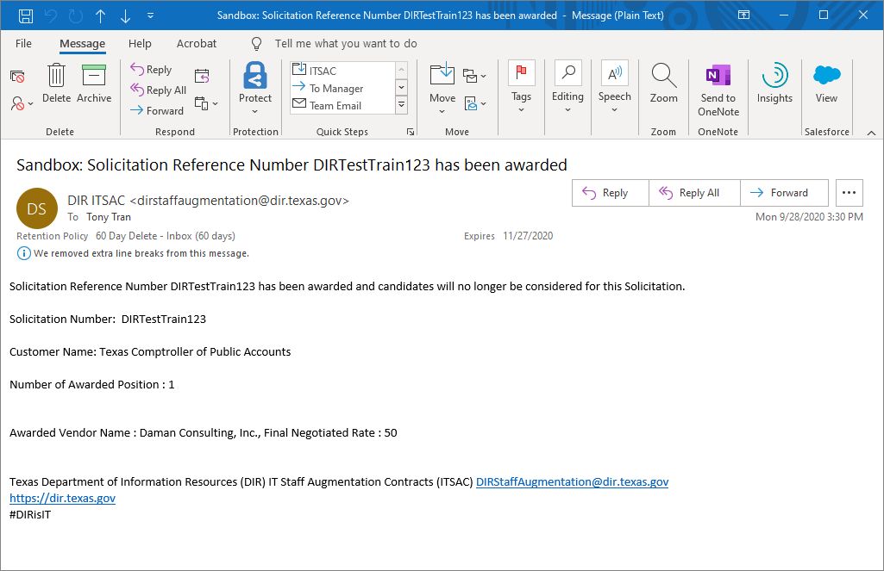

## **Submitting a Statement of Work (SOW) Solicitation**

Customers will be able to submit Statement of Works (SOW) to Vendors to propose solutions regarding IT Staff Augmentation Contracts. SOW examples may include staff on retainer over a period of time, a proposal of a team of different titles and positions to address an upcoming project, etc.

## Log into the ITSAC Customer Portal. On the banner, click on **Submit Statement of Work.**

## Enter the SOW details then click Next.

## Upload any documents associated with the SOW for Vendors to review. Click Next.

## Confirmation Message – The SOW has been drafted and is ready for review. Click Finish to return to the Home Screen.

## Once your agency has reviewed the draft, you may post it to eligible Vendors. Locate the Solicitation in Draft Status and click the Solicitation ID. You will be taken to the Solicitation Detail page.

## Review the details. If an edit is required, click on the ‘Edit Draft’ button.

If files need to be edited, click on the Upload Files button or Delete button under Solicitation SOW Documents.

You may also withdraw the Solicitation and no Vendors will be notified.

## Click the Post button to select Vendors for notification. Set a deadline date for Vendors to provide responses.

Note: For State Agency Customers (not including Higher Education), SOWs must be reviewed by DIR prior to posting to Vendors and must adhere to all guidelines under Texas Government Code 2157.068.

## Select the eligible Vendors to send the SOW Solicitation. Click Finish and notifications will be sent.

Email Notification:

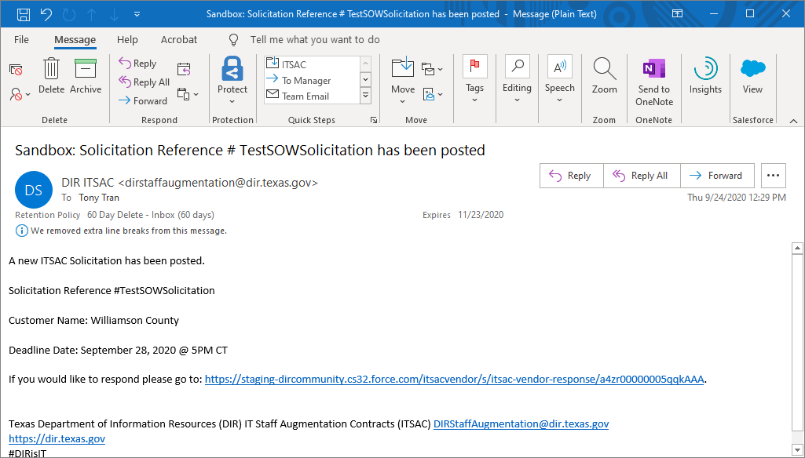

Once the deadline date has passed, check the SOW Response tab to begin review. If more time is desired for Vendor submissions, click on the Extend Deadline button.

At any time, you may Cancel the Solicitation and all eligible Vendors will be notified.

## **Awarding a Statement of Work (SOW) Solicitation**

Once the deadline date for a posted SOW Solicitation has passed, Customers may access the portal to review submissions. Reach out to potential vendors and begin negotiations for Award. Use the Portal to Award the SOW and close the Solicitation.

## Once the deadline date has passed at 5:00 PM Central, the Solicitation Status will change to ‘Customer Reviewing’.



## Click on the Solicitation ID of the Solicitation in the ‘Customer Reviewing’ Status. This will bring you to the Solicitation Details page.

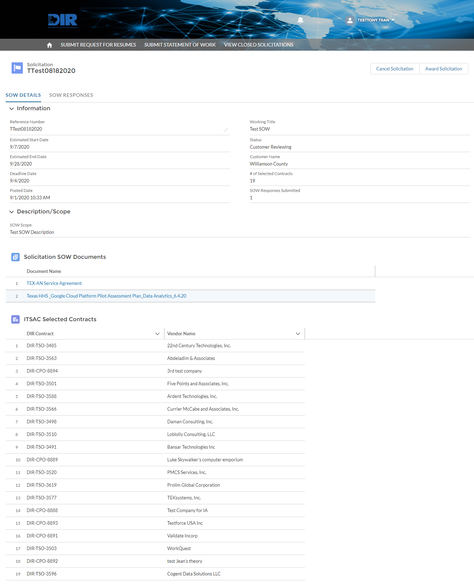

## Click on the SOW Response tab to view all Vendor responses. Click on either the SOW Response ID link or the Download buttons to review responses.

## Click on the SOW Response ID to view more details and view documents.

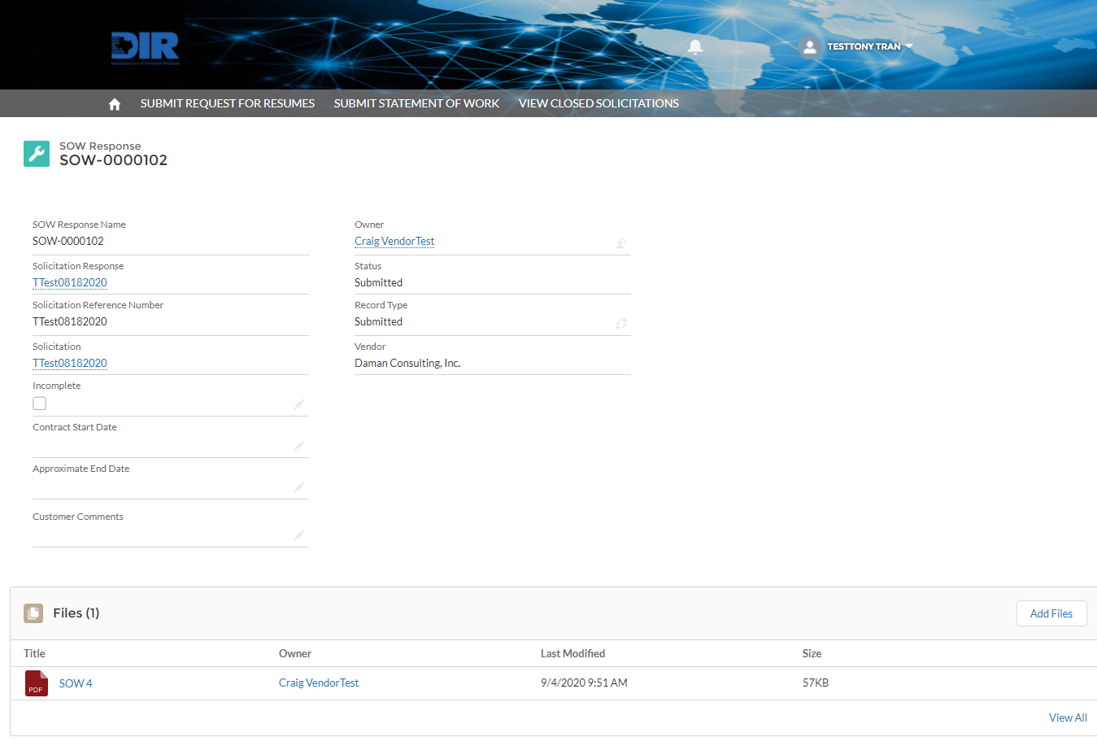

## Retrieve Vendor contact information by clicking on the Vendor Name.

Reach out to vendors and begin negotiations.

## To begin the Award process for a selected Vendor or Vendors, click on the **Award** button.

Note: You may cancel a Solicitation at any time.



Note: State Agencies must review all final SOW documents prior to Award.

## A list of notified Vendors will appear. Click on the Awarded column for each vendor that was Awarded the SOW solicitation.

You will be asked to enter Contract Start and approximate End Dates.

Once all vendors have been selected, click Save to Award and close the Solicitation.

A confirmation message will appear:

All eligible Vendors will receive an email notification that the Solicitation has been closed.

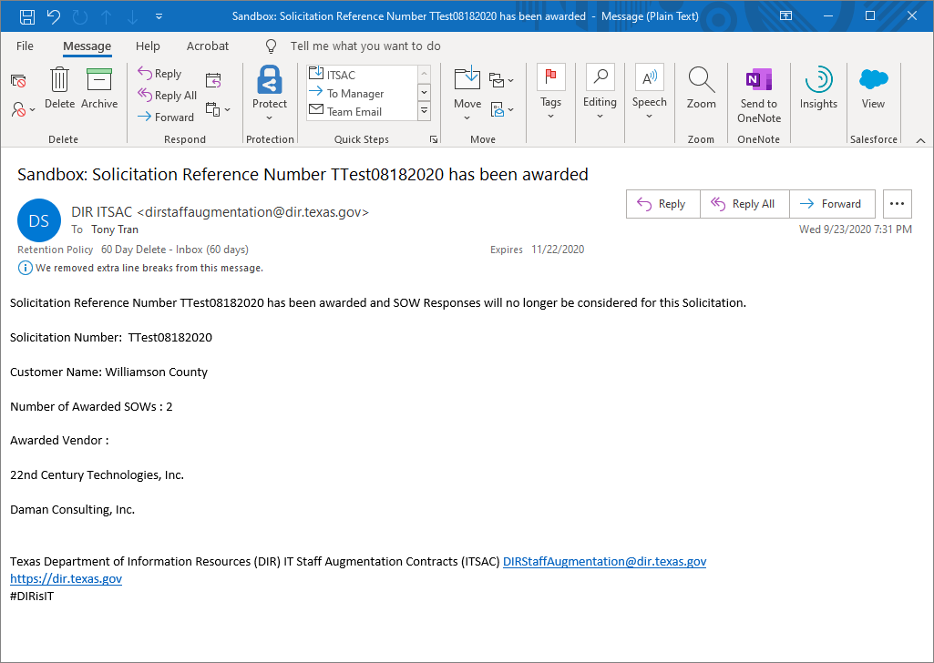

## **Cloning a Request for Resumes Solicitation**

Any Request for Resumes Solicitation posted in the Portal for RFO 445 may be cloned at any time to expedite the Solicitation process. SOW Solicitations cannot be cloned.

## Locate an Open Solicitation (on the Home Page) or a Closed Solicitation (on the View Closed Solicitation Tab) and click on the Solicitation ID.

Note: Any open Solicitation, regardless of status, may be Cloned. Only closed solicitations posted under RFO 445 may be cloned.

## The clone link can be accessed on the Solicitation page.

## Note: The link (depending on Solicitation status) can be accessed through a Down arrow or may be presented as a button.

Click on the Clone link to begin.

## The clone link can be accessed on the Solicitation page.

All details from the cloned Solicitation will be presented and can be edited. You must provide a new Solicitation Reference number.

## Once you have completed all the steps, click **Save Draft** and the Solicitation will be saved in Draft status. You may then review and either Withdraw the draft Solicitation or begin the Post process.

Confirmation Message. Refer to previous sections in this document to proceed with posting the Solicitation.

# Version History

|  |  |  |
| --- | --- | --- |
| Version Number | Release Date | Comments |
| 1.0 | 2/24/2020 | Initial Release |
| 2.0 | 3/16/2020 | Updated changes to include resume download file limit, allowing multiple accounts per customer, and displaying number of candidates posted prior to deadline date. |
| 3.0 | 10/1/2020 | Updated changes to reflect modified process to accommodate RFO 445. Added steps for SOW process and Cloning Solicitations process. |