How to set up legislative alerts using Texas Legislature Online (TLO)

Step 1: Navigate to the TLO URL: https://capitol.texas.gov/Home.aspx
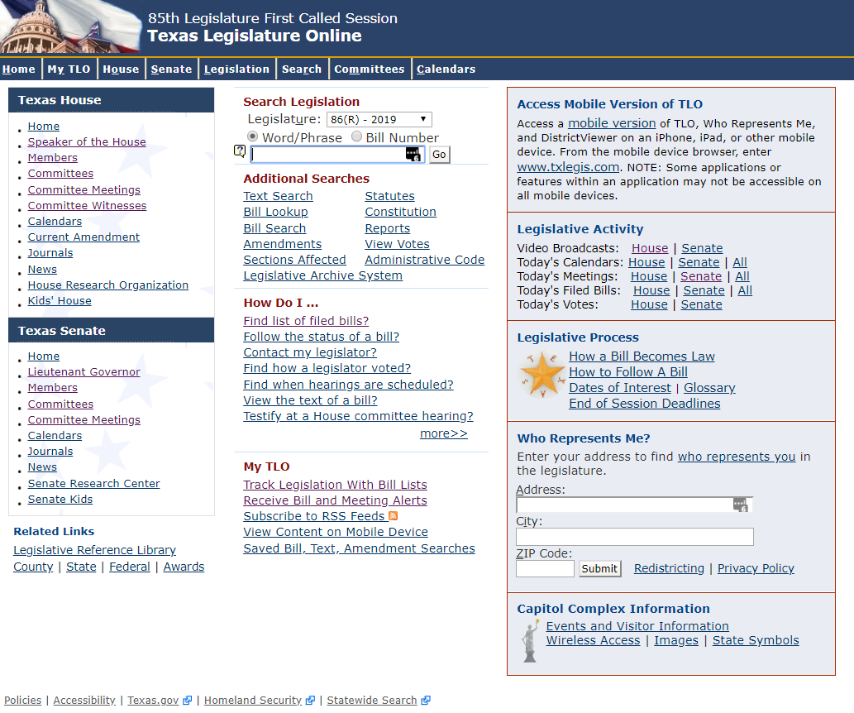

Step 2: Select “My TLO” from the top navigation pane, then select “Alerts”
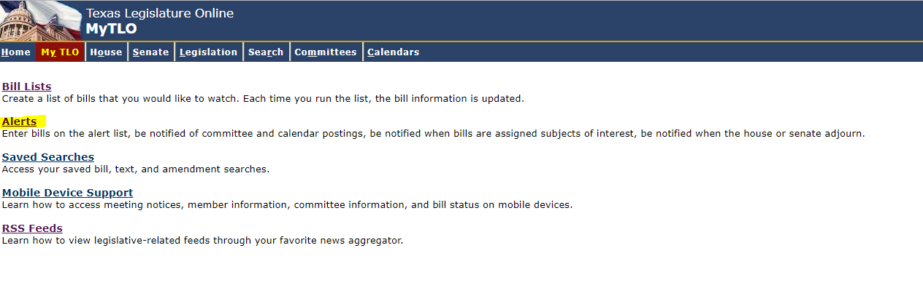

Step 3: Select “new user” to register for an account, or log-in with your existing account. Be sure to use the email address that you would like to receive alerts.
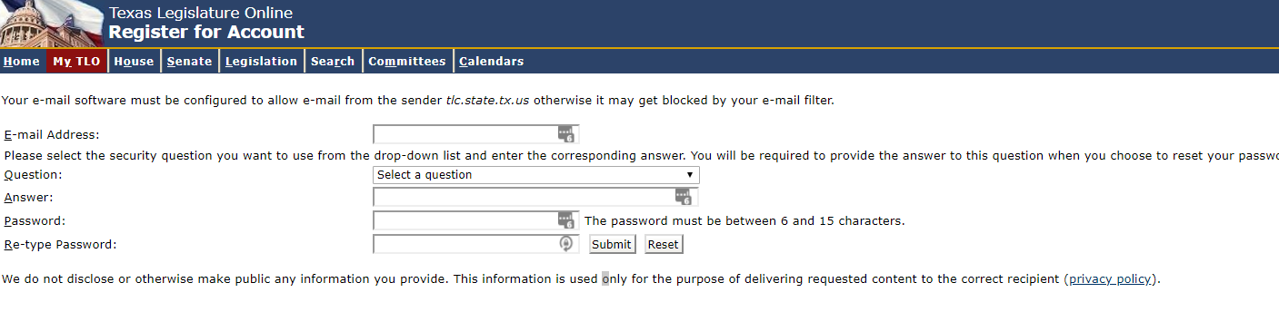
Step 4: Alerts can be set up for specific bills, calendars, committee meetings, subjects, and more. To set up alerts for information technology or other topics, select “subjects.” IT issues are primarily captured in the “electronic information systems” subject.
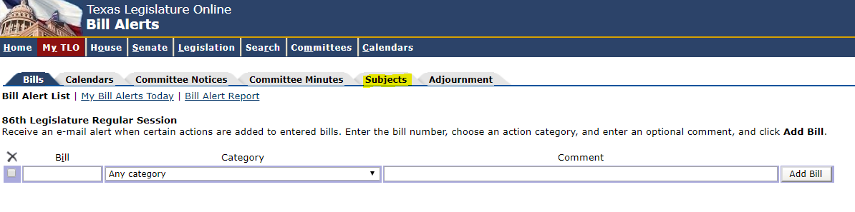
Step 5: On the subjects page, expand the second panel to show the entire list of subjects. Select the subjects that you would like to receive notices about. 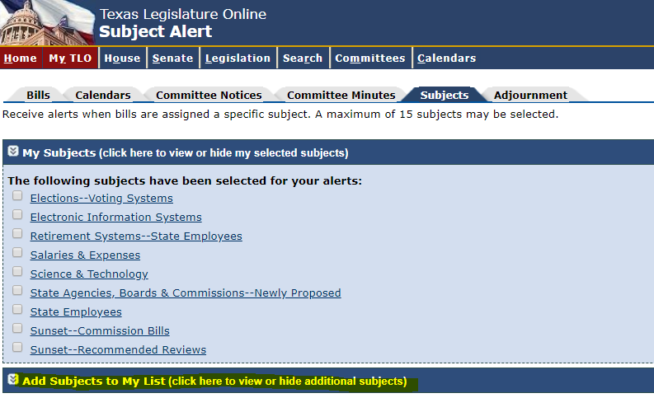
Step 6: Clicking on the subject will show you all the alerts for you specified session:
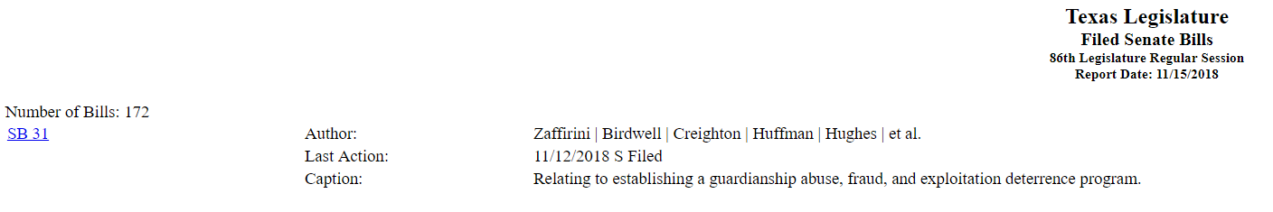

You can set up a variety of alerts according to your preferences, e.g. by specific bill:
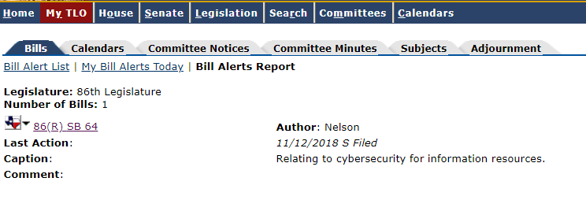
It may also be helpful to create lists and organize various bills into categories:
